Provisioning via Users

An employee missed the setup and can't log in with Visma Connect. How can I fix this?
It's a quick fix. If you're an administrator, just go to the Users view, enter the employee's email address, and send a new verification message.
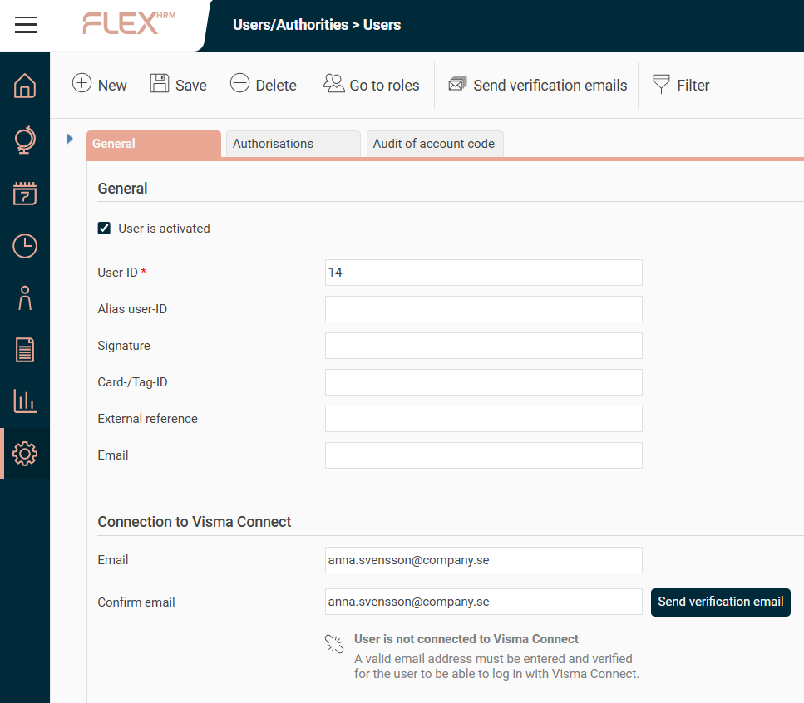
They'll get an email with a link to click. Once their address is verified, their Visma Connect account is activated.
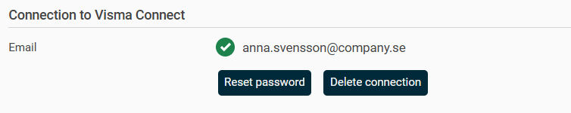
From there, they can set their own password using the "Forgot your password?" link on the login page.

How can I send verification emails to many employees at once? 🧑‍💻
Need to send verification emails to a group of employees who still haven't verified their accounts? No problem, it's a straightforward process.
You don't have to worry about accidentally spamming colleagues who are already set up. The system is smart enough to only send the message to users with a saved email address that is still pending verification.
- Head over to the Users view in Flex HRM.
- In the toolbar above your user list, click the Send verification messages button.
- Here's a tip: To send the email to a specific group, like a certain department or office, just use the search and filter tools to narrow down your list first.
When you hit the button, the verification emails will be sent out to everyone in your selection.
Painless, right? 😉
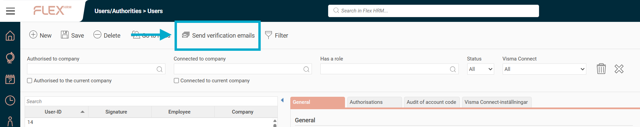

What if my employees don't have an email address saved in the system? 📧

Great question! This comes up a lot. If you have many users without a saved email address, the easiest way is to use the import tool.
We've added the Email Visma Connect field to the Employees/users import and export templates, so you can add everyone's email address in one go.
Just a heads-up: You can only import email addresses for users who aren't already connected to Visma Connect. The system will also automatically ignore any invalid email formats you try to import.

