Get Started with Visma Connect (Desktop)
- You will see a message at the top of the page when you are logged into Flex HRM. The message will be displayed until you have followed the instructions and linked your user to a Visma Connect account. Click the button in the message to go to Account Settings.
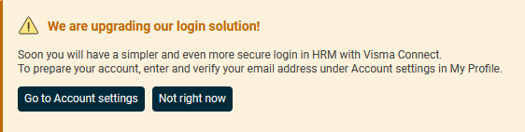

- Enter or select one of the suggested email addresses and click the button to have a verification code sent to you.
Please note: Depending on your settings, an account can be created without a verification message being sent. In such cases, steps 3 and 4 will be skipped.
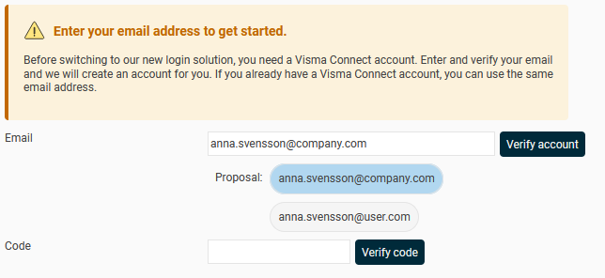

- Open your email inbox and the following email:
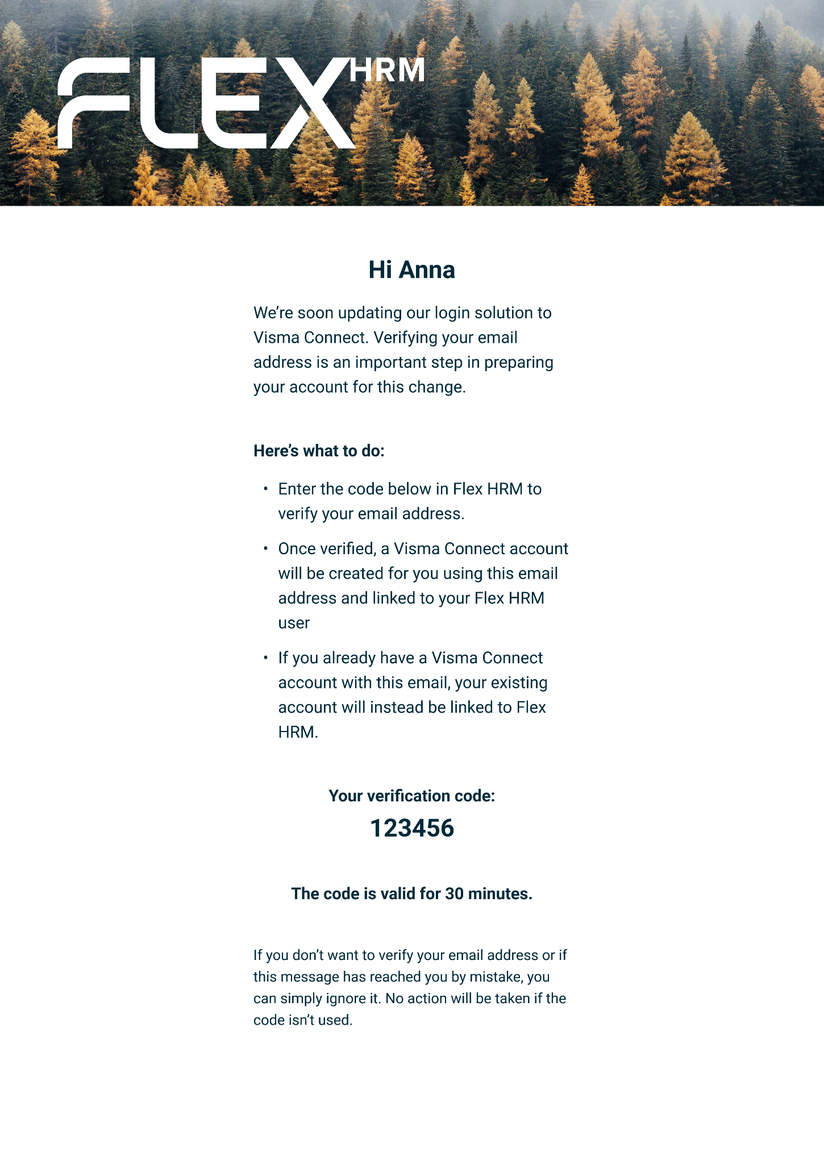

- Return to Flex HRM, input the code into the code field, and click the button "Verify code."
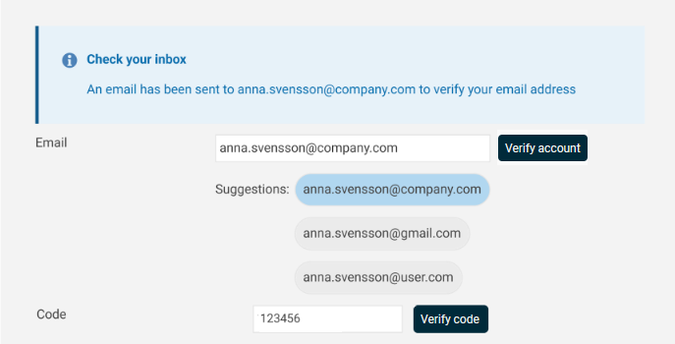

- You're done!
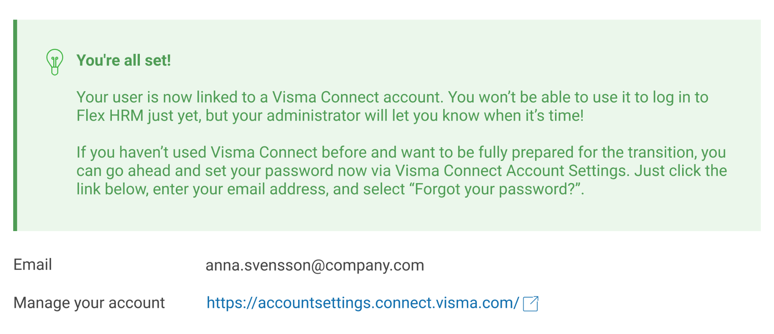

Steg by Step (Mobile)
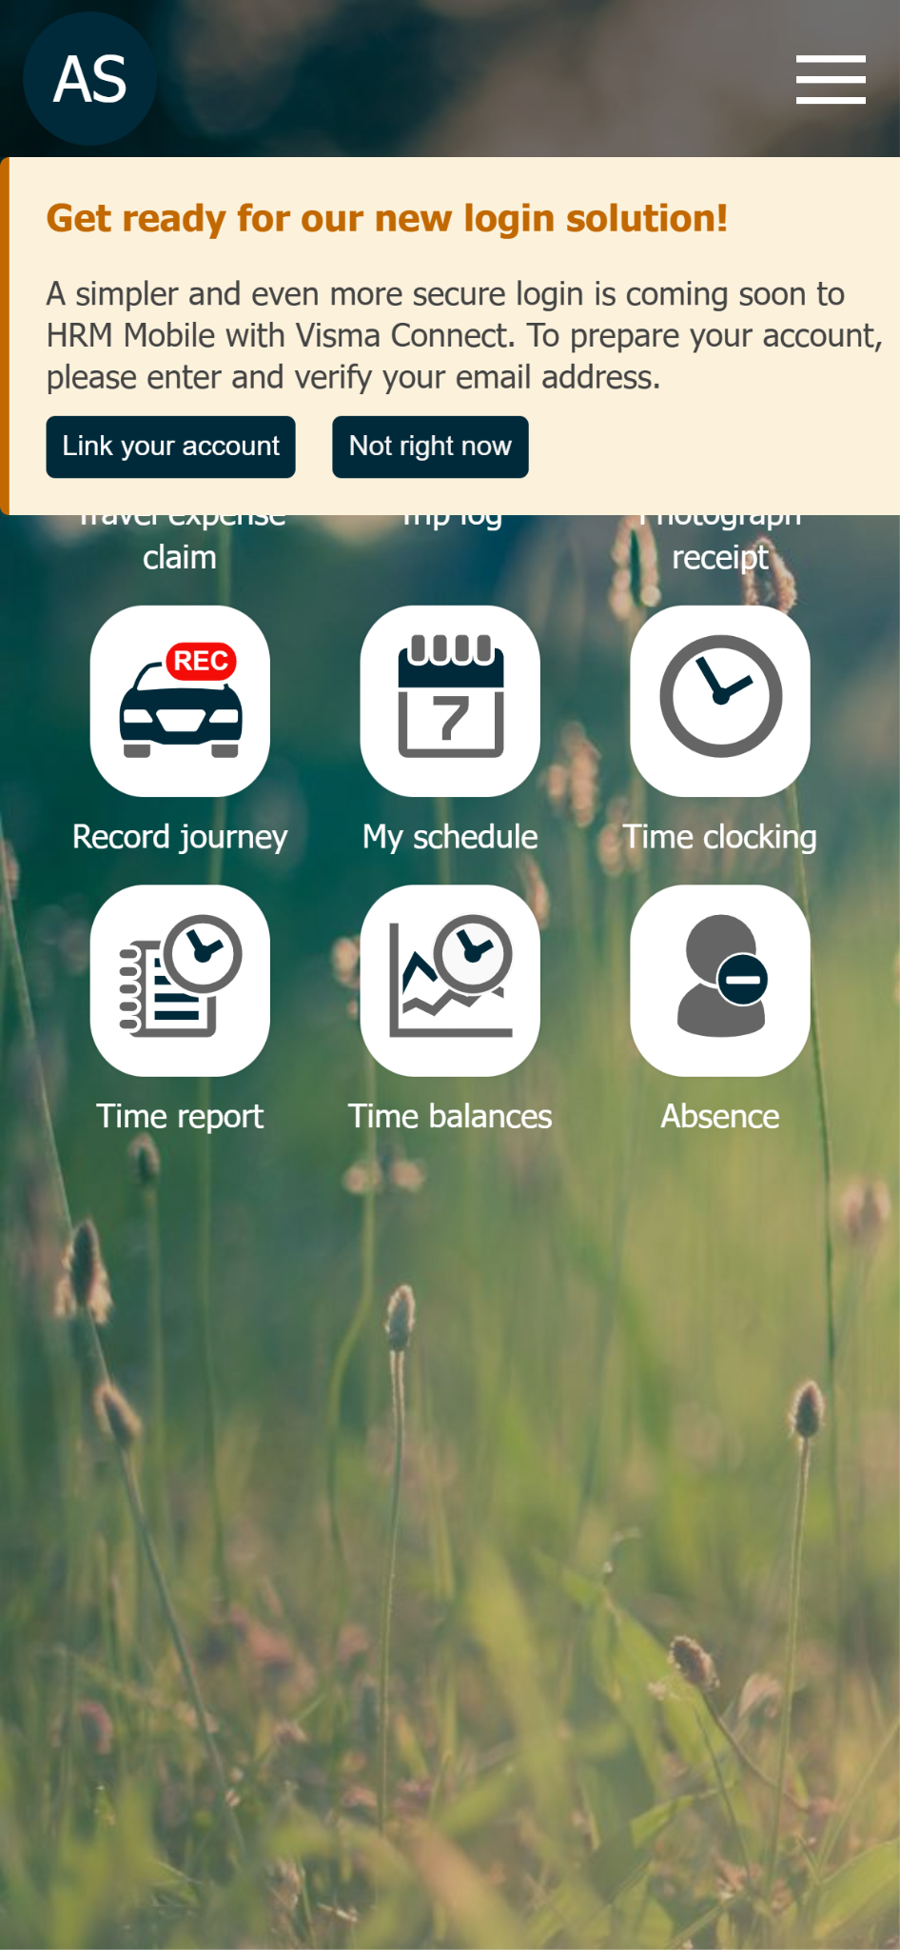
 | 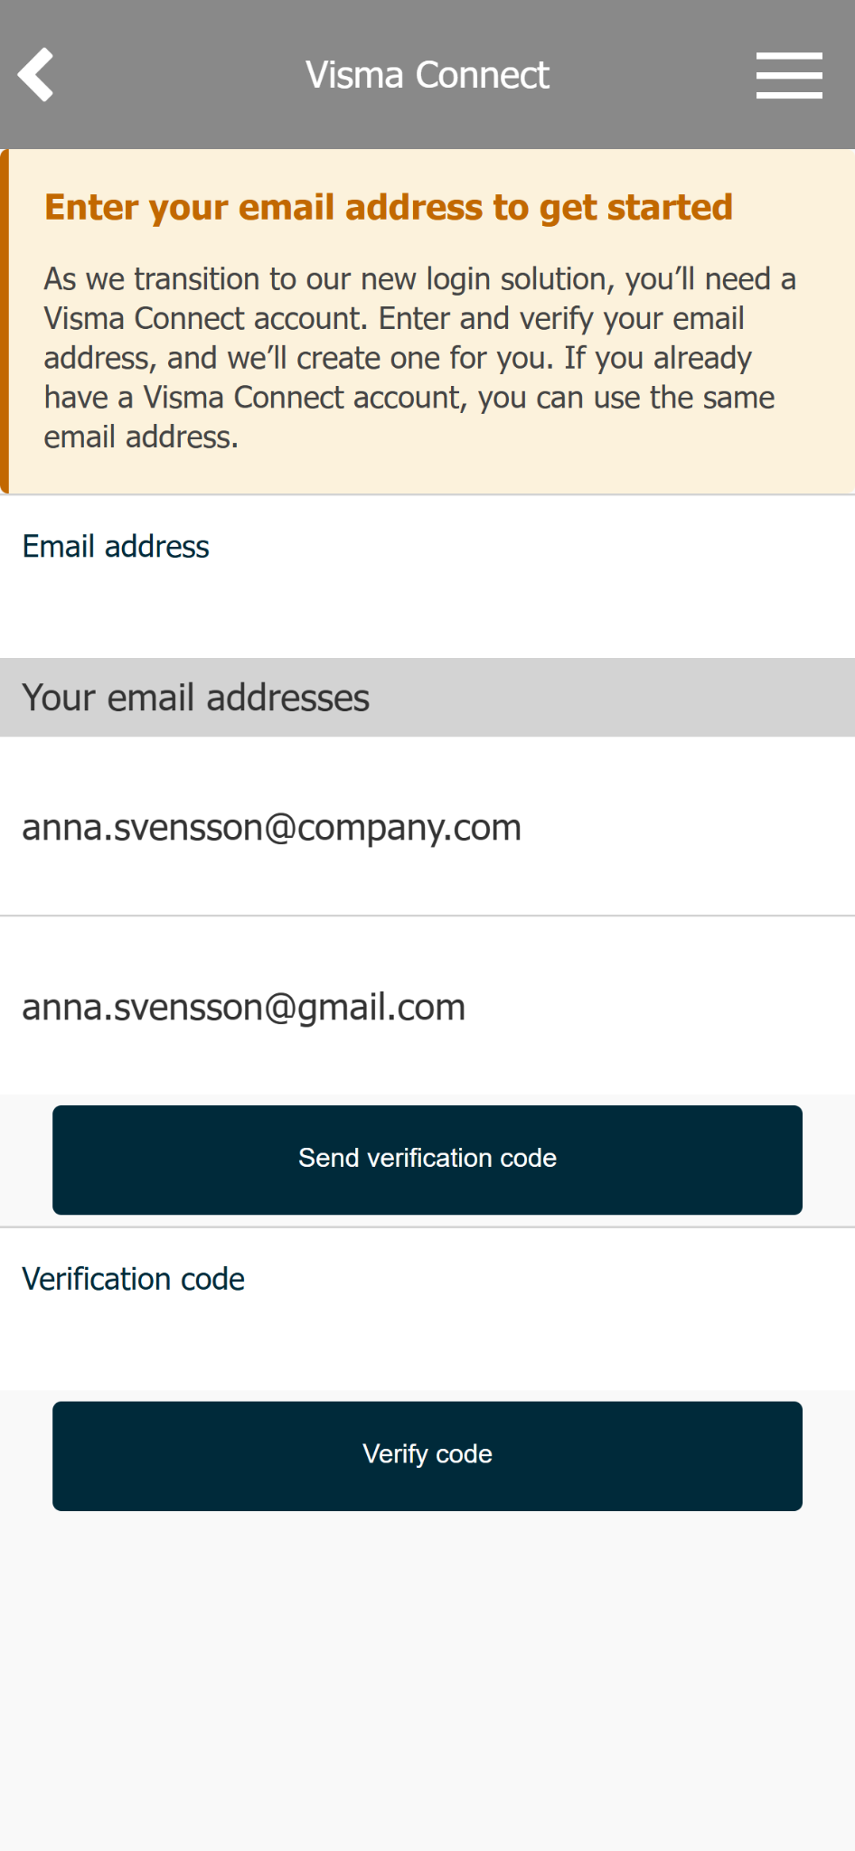
- This message appears at the top of the screen when you are logged into Flex HRM Mobile. Click the "Connect your account" button in the message to get started.  You can choose to hide the message temporarily; it will reappear after 24 hours if you have not prepared your account. You will also find the verification page under Settings > Visma Connect. | - Enter or select one of your suggested email addresses and click the "Send verification code" button.  Please note: Depending on your settings, an account can be created without a verification message being sent. In such cases, steps 3, 4, and 5 will be skipped.
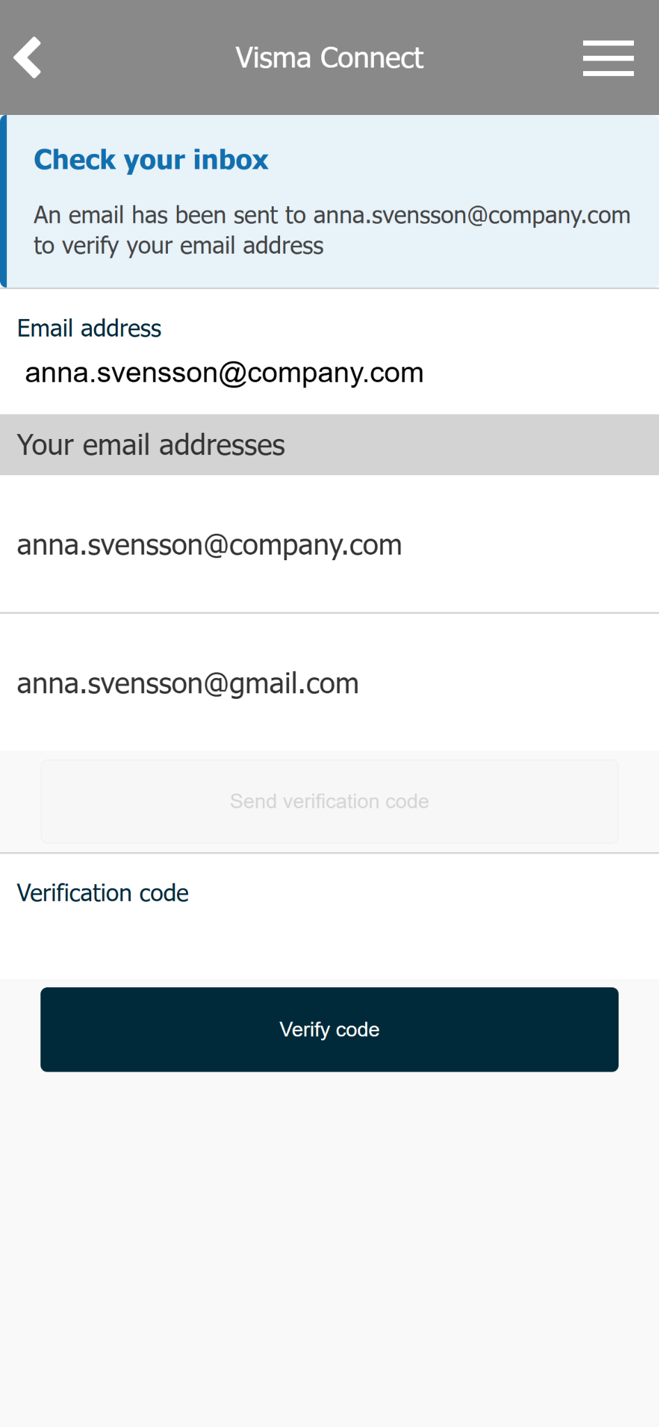
- An email will be sent to the email address you provided. | - Open your email app and find the message above. Copy your verification code.

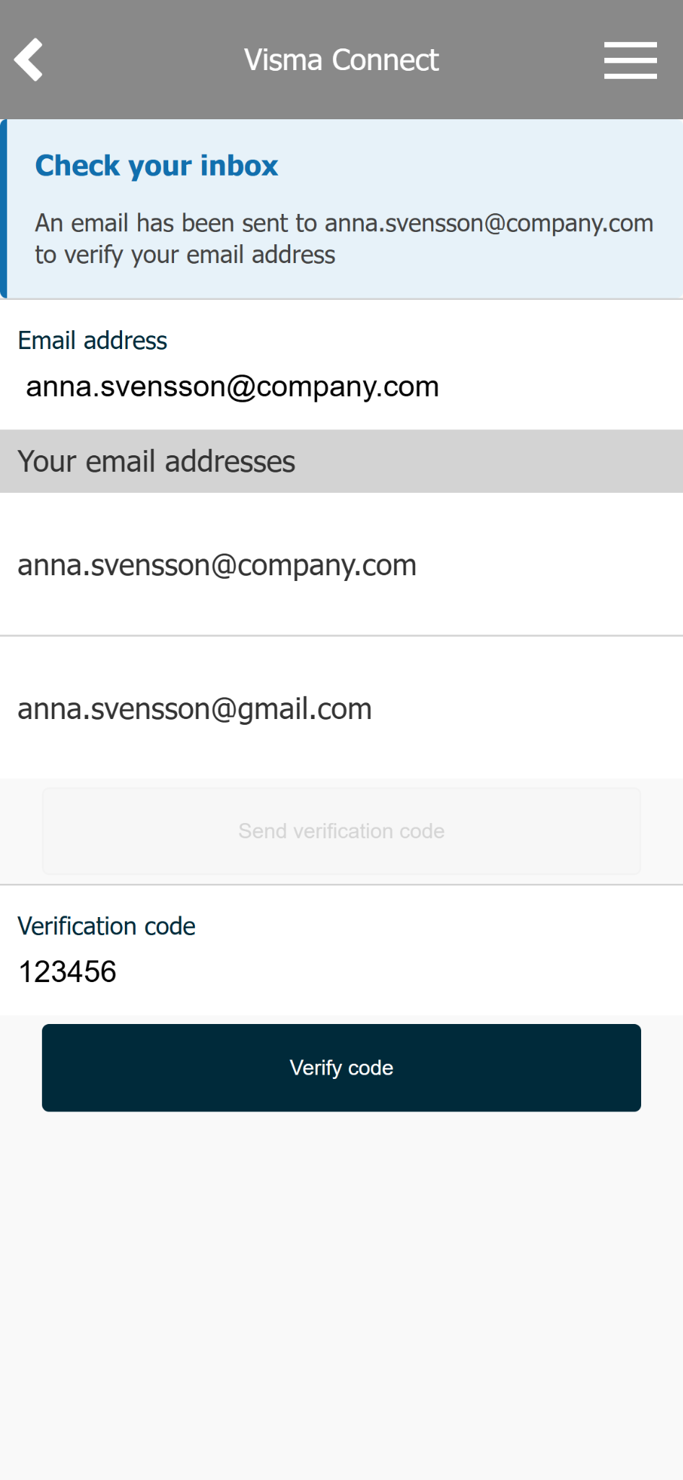
 | 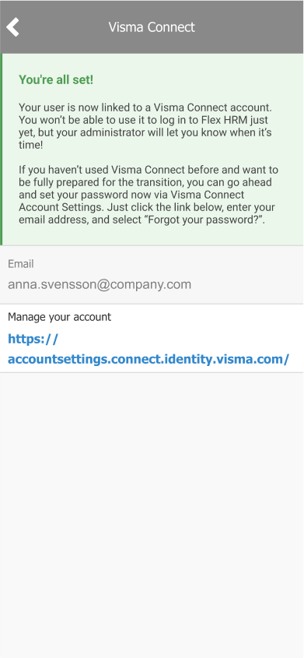
- Paste or type your verification code into the field and press the "Verify Code" button. | - You're done! If you'd like, you can continue by creating a password using the link under "Manage your account."

