Admin Guide: The New User Login Experience

To best help you prepare and support your colleagues for the switch to our new login solution, Visma Connect, we've created this guide.
Here, we'll walk you through the entire process step-by-step, exactly as your users will experience it. The guide is split into two parts: first, a visual walkthrough of the user journey, followed by a Frequently Asked Questions (FAQ) section.
Our goal is to ensure you feel confident with the process and can easily assist if any questions arise.
Let's begin with the user journey!

User journey (Desktop)
1. During the provisioning period, users will see a banner displayed at the top of all pages in Flex HRM until they link their user to a Visma Connect account. The banner prompts the user to prepare their account by going to Account Settings.
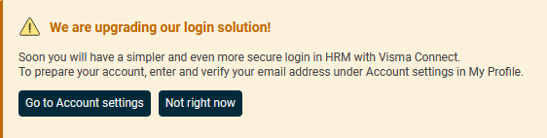

2. Under My Profile > Account Settings, the following banner is displayed which prompts the user to enter and verify their email address:
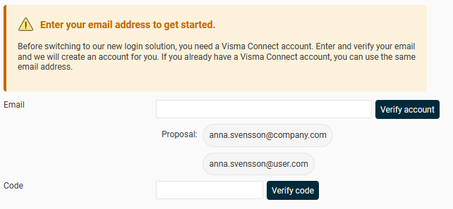
3. The user can select one of the suggested email addresses or enter a different email address. The email addresses that are suggested are those that are saved on the user or the employment with mailings activated.
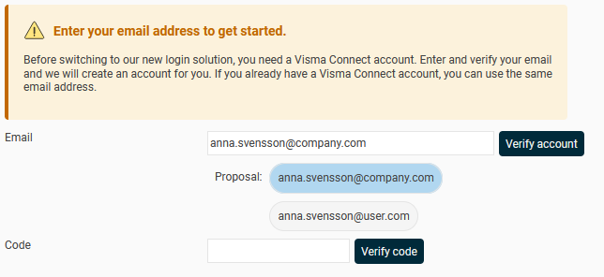

4. When the user has selected or entered an email address, they can click the button to send an email with a verification code to the specified address.
Please note: If you have a verified domain under General > Security, and the email address belongs to this domain, the account will be created immediately without a verification message being sent. In such cases, steps 5 and 6 will be skipped.
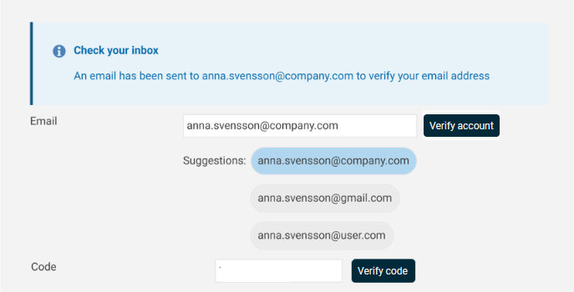

5. The user will receive the following email:
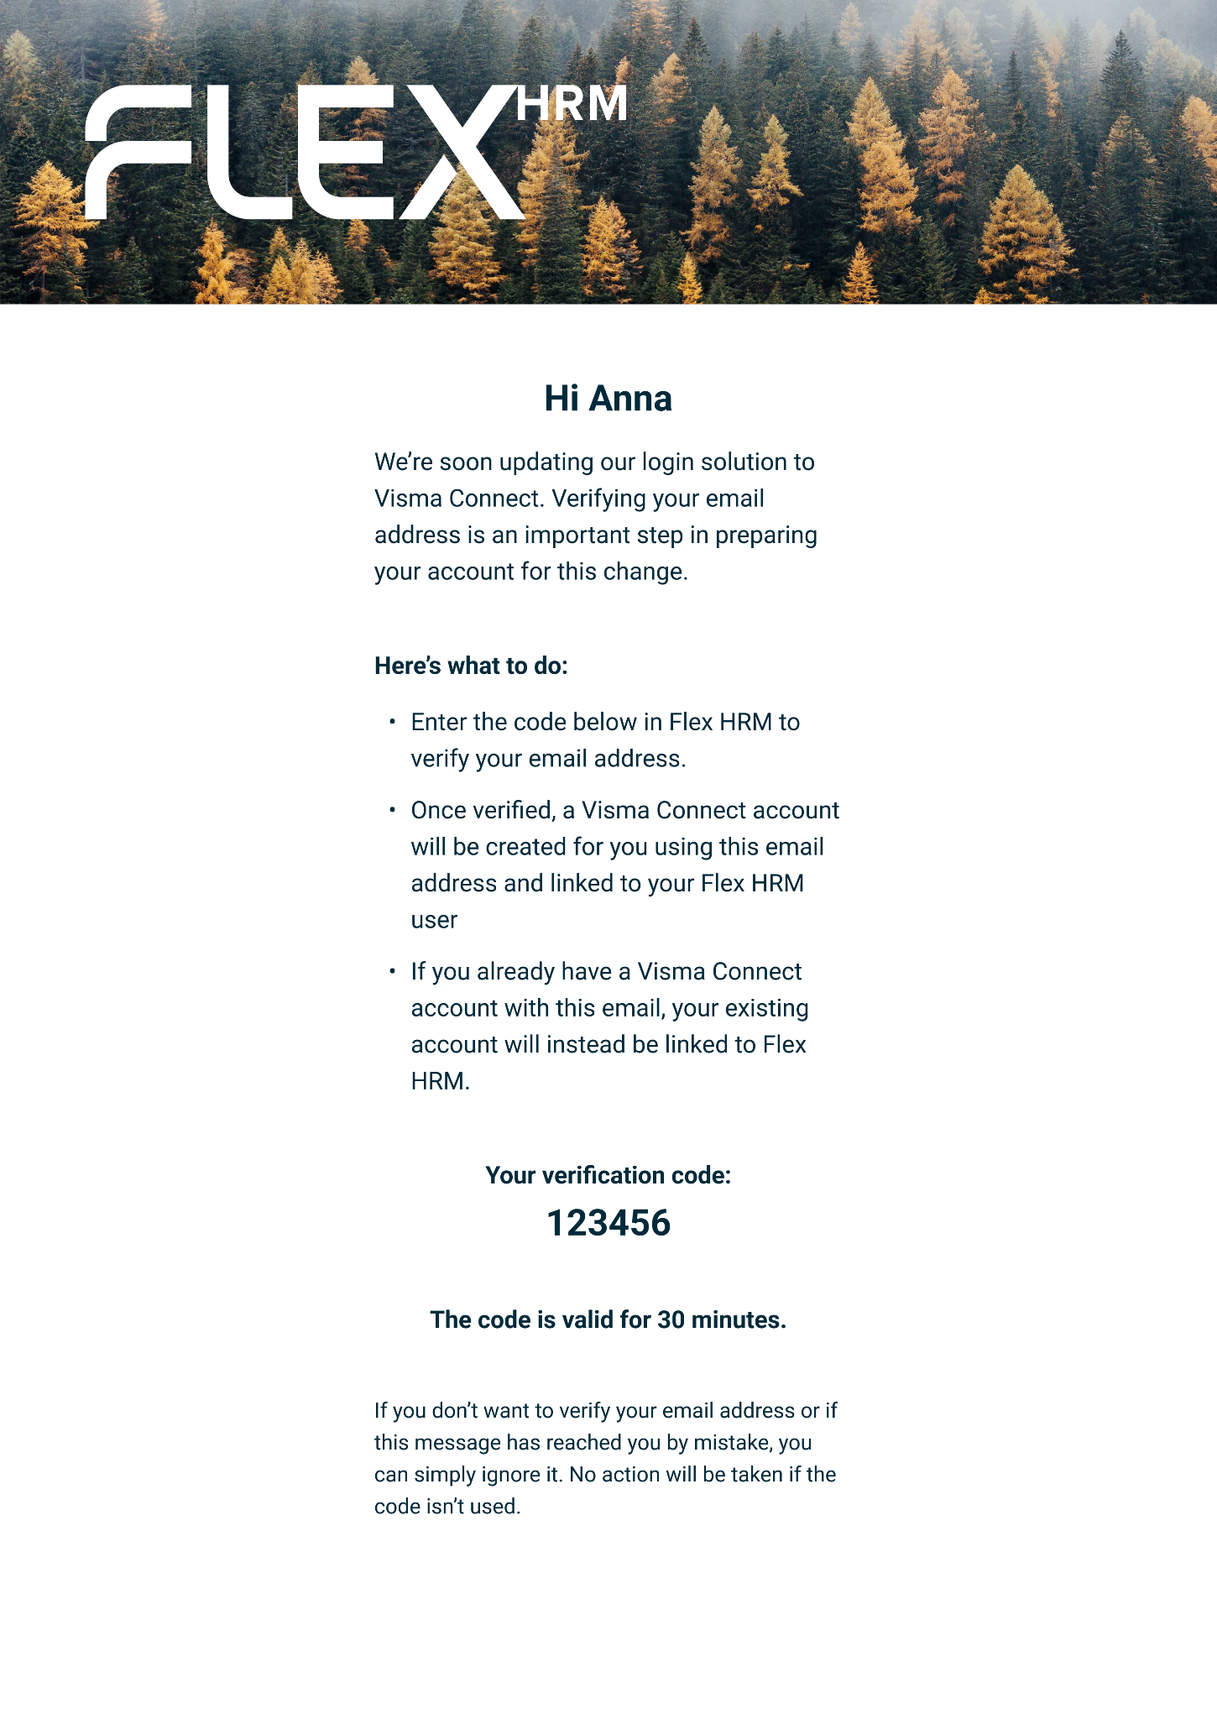

6. The user should now go back to Account Settings in Flex HRM, enter the code in the code field and click on the “Verify code” button.
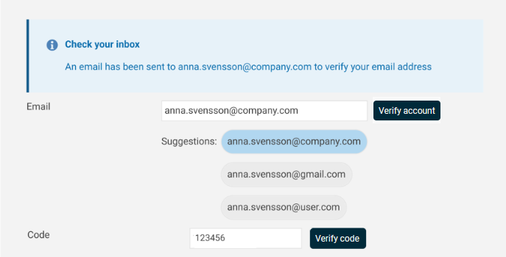

7. Now the user is connected to Visma Connect and thus fully provisioned. The user can at this stage choose to create a password for the account through Visma Connect Account Settings.
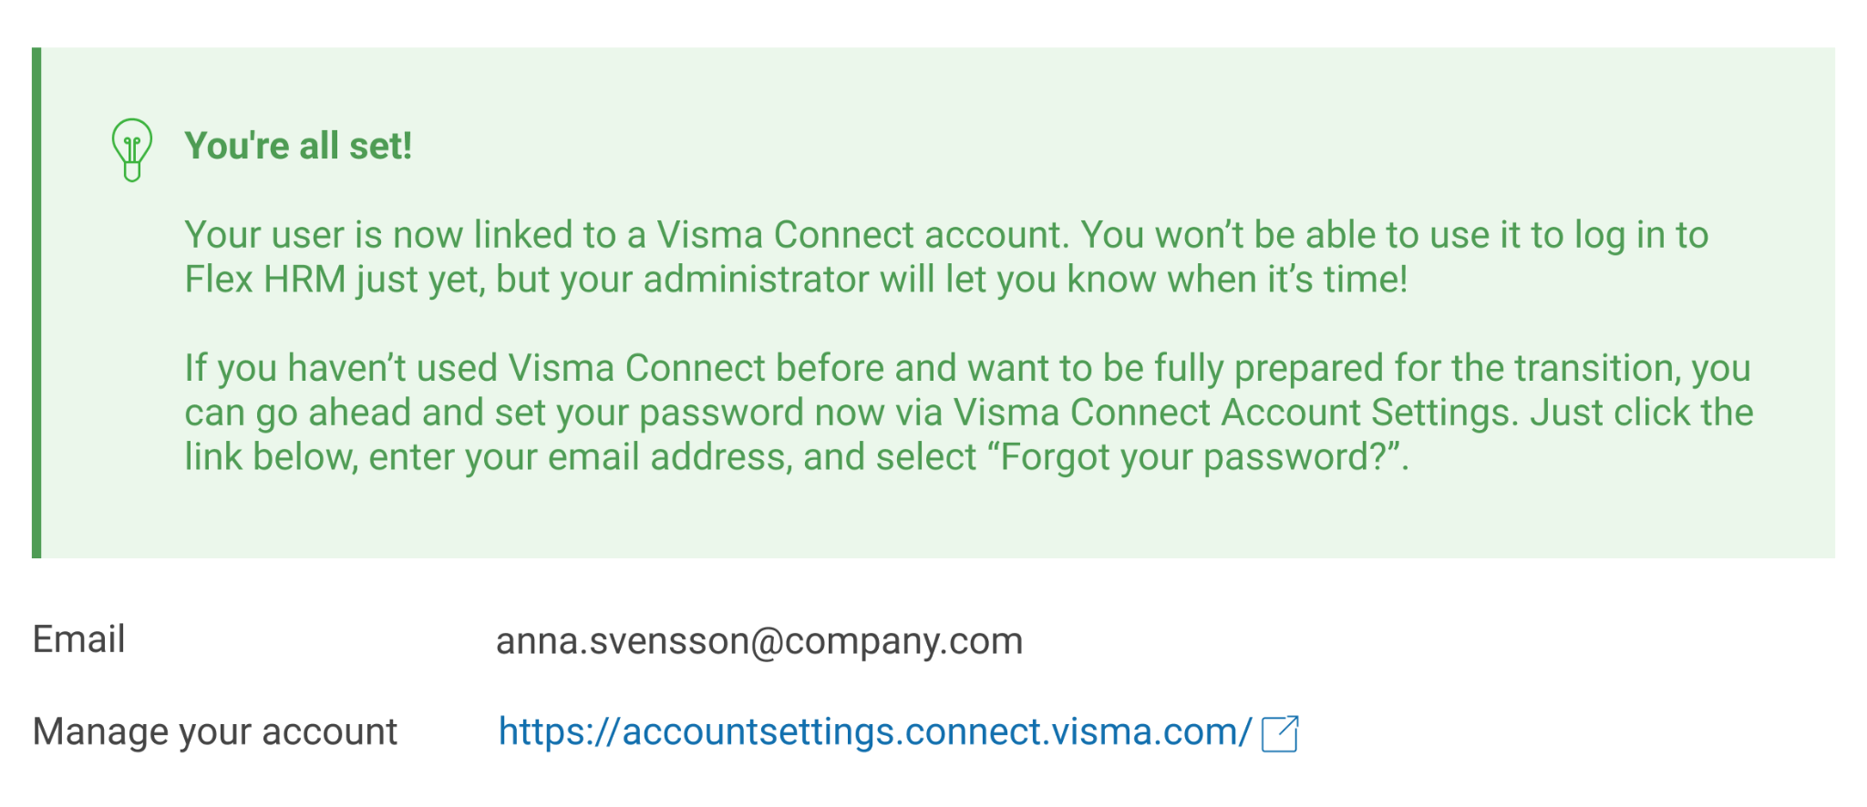

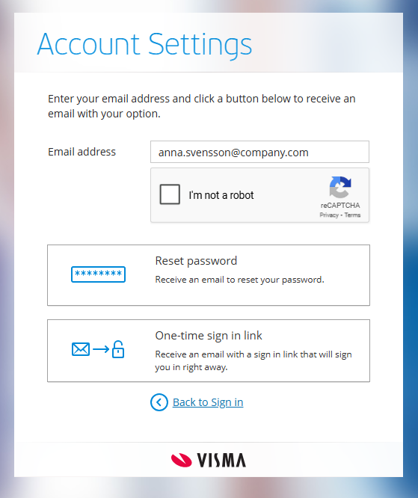
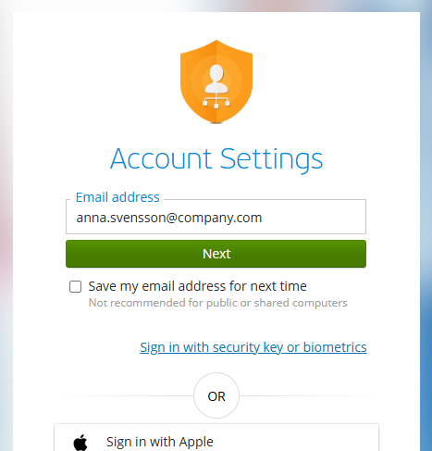
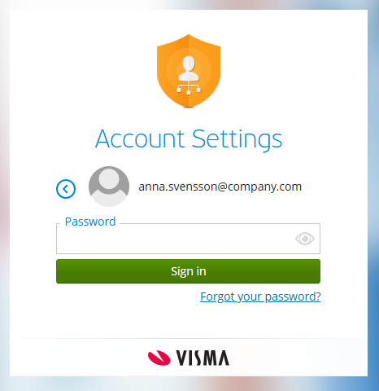
Create a password before the transition

FAQ

An employee was absent during provisioning and cannot log in now that we have switched to Visma Connect, what do we do now?
An administrator with authorization to the Users view can enter an email address and send a verification message to the user. The user will now receive a link to click on to verify their email address.
Please note: If you have a verified domain under General > Security, and the email address belongs to this domain, the account will be created immediately without a verification message being sent.

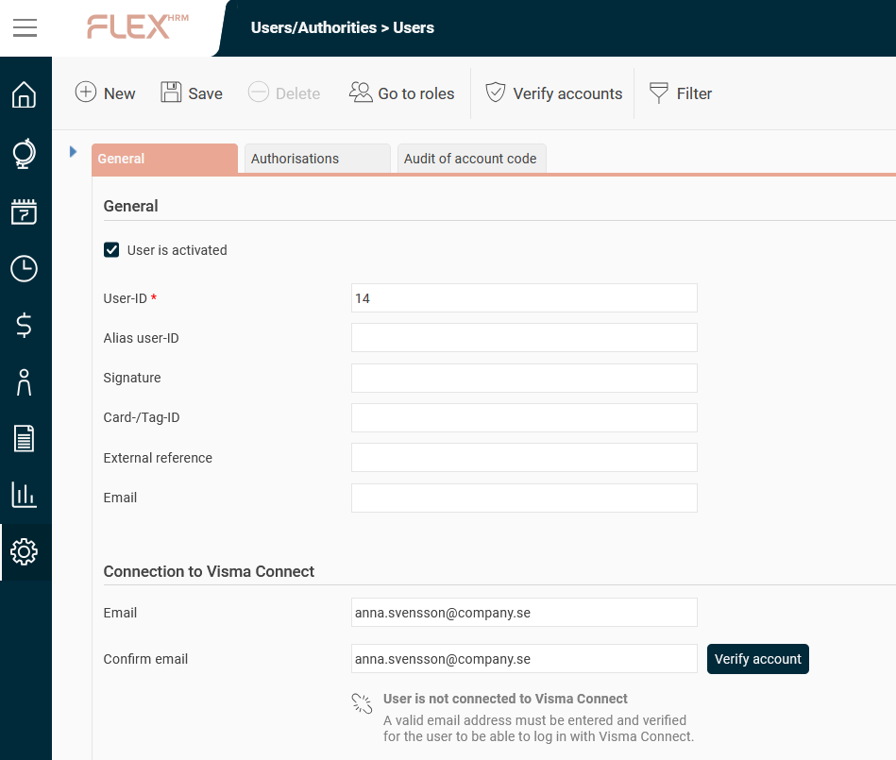
When the user has verified their email address, the user is linked to Visma Connect.
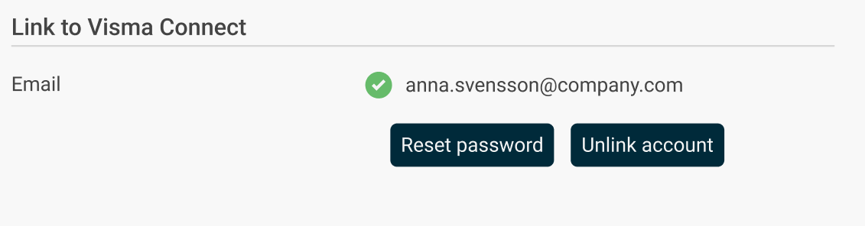
After that, the user can create a password through "Forgot your password?" on the login page.

An employee has used a private email address instead of the company's to link their HRM user to Visma Connect, how do we change it?
- Remove the connection
An administrator with authorization to the "Users" view must first delete the current Visma Connect connection.
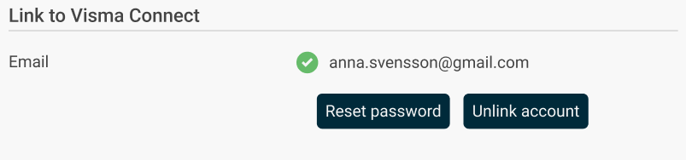
- Connect a different email address
- If you are still in the provisioning period (preparation phase), the user will again see a banner at the top of Flex HRM when the link is removed. The user can then go to My Profile > Account Settings and redo the link with the correct email address.
- If you are already using Visma Connect for login, the administrator can update the email address manually:
  - Enter the new email address for the user in the "Users" view.
  - Send a new verification email to the new address.
Please note: If you have a verified domain, and the email address belongs to this domain, the account will be created immediately without a verification message being sent. Step 3 can then be skipped.
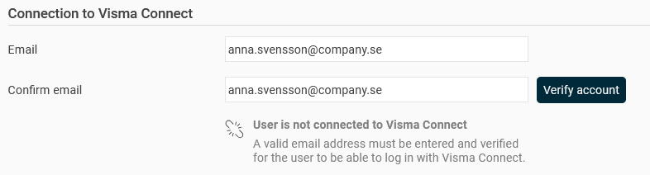
- Complete the connection
The user clicks on the link in the verification email to confirm the email address.

We want all employees to use only their email addresses ending with '@company.com' when connecting their HRM user to Visma Connect. How can we enforce this restriction?
You can find a new section for specifying allowed domains for connecting to Visma Connect by navigating to the General > Security page. This is where you can list the domains you wish to permit.
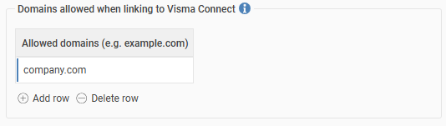

It's crucial to configure the allowed domains before the preparation phase begins, as this setting will not affect users who are already connected. If no domains are specified, all domains will be allowed during email verification and, consequently, the connection to Visma Connect.
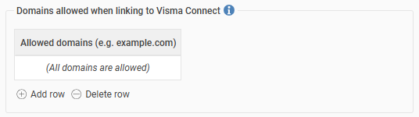

We want to be able to import and export email addresses. Is this possible?

Yes, it is!

The field "Email Visma Connect" is now available to choose in import and export templates of type "Employees/users". If an invalid email address is entered, the field will not be updated.
Note that it is only possible to import emails for users not linked to Visma Connect.

