Verify domain for automatic creation of accounts

Flex HRM can create new users in Visma Connect automatically if your company has verified its domain. With this solution, a verification email does not need to be sent to the employee.

Authentication Settings
Authentication Settings is a self-service portal where you as an administrator can manage and configure Single Sign-On (SSO) and verify your domain. If you are an administrator in Flex HRM, you can assign permissions to Authentication Settings under General > Security in Flex HRM.
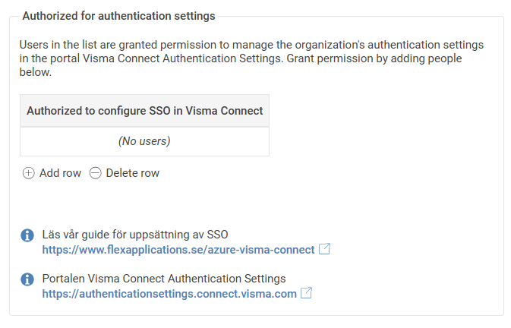
Read our guide for setting up SSO https://www.flexapplications.se/en/azure-visma-connect
The Visma Connect Authentication Settings portal https://authenticationsettings.connect.visma.com

So, for example, if you want to give IT staff permissions, you click on “Add row” as shown in the image above and search for the user you want to give the permission to. Then press “Save” in the upper left corner.
Keep in mind that if you want to have permission to Authentication Settings yourself, you also need to grant permissions to your own account.
You can access Authentication Settings at the following link: https://authenticationsettings.connect.visma.com For more detailed information about Authentication Settings, see the documentation at the following link: https://docs.connect.visma.com/docs/authentication-settings

Verify domain
For the feature to work, you need to verify your domain in Authentication Settings. You can do this by following the guide at the following link: https://docs.connect.visma.com/docs/domains
When everything is done, you can see which domains are verified in HRM General > Security.
