Azure - Important Changes
Certain changes will occur with the move to Azure. Below is a list of changes that need to be
reviewed for Flex HRM to continue functioning correctly.

📍 New IP Address
In Azure, we have a new IP address: 4.223.138.189. It’s important that you notify your IT department about this, as it may need to be added to various allow-lists for integrations, SFTP (remote folders), and similar services.
🌐 New URLs
- Flex HRM: web.flexhrm.com
- Flex HRM Mobile: mobile.flexhrm.com
- Flex HRM API: api.flexhrm.com
🕙 New URL for Flex HRM Timeclock
The URL needs to be changed to timeclock.flexhrm.com and “/Timeclock” needs to be removed. In some cases, the customer number needs to be added.
Examples:
- "customer.flexhosting.se/Timeclock" => "timeclock.flexhrm.com/default/kundnummer"
- "customer.flexhosting.se/Timeclock/Fabriksklocka" => "timeclock.flexhrm.com/Fabriksklocka/kundnummer"
- "exempel.com/Timeclock/Fabriksklocka/1234" => "timeclock.flexhrm.com/Fabriksklocka/1234”
📅 Subscribe to Schedule

If users utilize the “Subscribe to Schedule” function, where they can see their schedule in, for example, Google Calendar, this subscription will need to be redone. If the user does not redo the subscription, their schedule will no longer be updated in their chosen calendar.

To redo the subscription: Cancel the subscription in your chosen calendar (Google, Outlook, iPhone, MacOS). Go to the start page in HRM. Click on “Subscribe” at the bottom of the Calendar widget and follow the instructions on how to add the subscription again.

💿 Cannot write to local path - Switch to SFTP

If you use program links, file exports, credit card imports or payroll files that write to local paths, these need to be replaced with SFTP.

🔒 Login with Visma Connect

In connection with the move to Azure, we are replacing our old authentication with Visma Connect to increase security and improve the login user experience. More information about Visma Connect can be found here. Note that this applies to Flex HRM and Flex HRM Mobile.

✉️ Email Required for Login in Flex HRM and Flex HRM Mobile

To log in to Flex HRM and Flex HRM Mobile, the user must provide an email address in the system. Flex HRM Timeclock and Flex HRM API will continue to use the same login as before, without the requirement for an email.

🔌 Integrations with the Public API (Flex HRM API)

Flex HRM API will continue to use Basic Auth with the same username and password as before. However, there will be a new URL, api.flexhrm.com. The API documentation can be found here.

💰 Classic Payroll - New URL for Integrations

For those who still use Classic Payroll in combination with Flex HRM, you need to go in and change the URL for the Flex HRM API. This is done under the menu item Settings -> Control Information under the Communication tab. Click on the Connections button and select the FLEX HRM tab in the popup. Replace your existing URL with the new one, but leave the username and password as before.
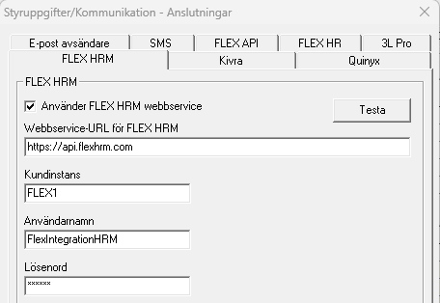

✉️ Shift Requests

With the move, the URLs for shift requests in Plan also change. The effect of this is:

Email: Shift requests sent before the move to Azure will not work after the move, as these will point to the wrong URL.

SMS: In order for SMS to function as usual, the callbackURL setting at https://ip1sms.com/
needs to be updated. Information on how to update this can be found in HRM under Settings → Import/Export → Program links, and then select Ip1 as the program link.

The change in ip1 must be made after the migration. SMS shift requests sent before the migration will be possible to respond to once the callbackURL in ip1 has been updated.

